Blockchain and it’s Applications
Question Bank Unit 1 Missing
- Explain the importance of hashing with respect to blockchain
Ans .1) Hashing plays a crucial role in the functioning and security of blockchain technology. Here are some key points highlighting the importance of hashing in the context of blockchain:

1. Data Integrity: Hash functions are used to create a unique digital fingerprint of data. In a blockchain, each block contains a hash of the previous block's data. This forms a chain of blocks where any alteration in the data of a block will change its hash, thus breaking the chain. This feature ensures the integrity of the data stored in the blockchain [T2].

2. Tamper Detection: Hashing helps in detecting any tampering or unauthorized changes to the data stored in a block. If any part of the data is altered, the hash of that block will change, alerting the network to the presence of tampered data. This tamper-evident property makes it extremely difficult for malicious actors to alter the data stored in the blockchain without being detected [T1].

3. Security: Cryptographic hash functions used in blockchain are designed to be one-way functions, meaning it is computationally infeasible to reverse-engineer the original data from its hash. This property ensures that the data stored in the blockchain remains secure and private [T4].

4. Efficiency: Hashing allows for quick verification of data integrity. By comparing hash values, nodes in the blockchain network can efficiently validate the consistency of the data across the network without the need to compare entire blocks of data [T6].

5. Linking Blocks: Hash pointers are used to link blocks in a blockchain. Each block contains the hash of the previous block, creating a chronological and immutable chain of blocks. This linking mechanism ensures the transparency and traceability of transactions recorded in the blockchain [T3].

Hashing in blockchain technology ensures data integrity, tamper detection, security, efficiency in data verification, and the linking of blocks to form an immutable chain. These properties make hashing a fundamental component of blockchain systems, providing trust and reliability in decentralized networks.
- Explain how and why SHA 256 is used in Blockchain
Ans.2) SHA-256 (Secure Hash Algorithm 256-bit) is a cryptographic hash function that plays a significant role in blockchain technology, particularly in the context of cryptocurrencies like Bitcoin. Here is an explanation of how and why SHA-256 is used in blockchain:

1. Data Integrity: SHA-256 is used to generate a unique fixed-size hash value (256 bits) for a given input data. In blockchain, each block contains the hash of the previous block's data. This chaining of blocks using SHA-256 ensures the integrity of the entire blockchain. Any modification to the data in a block will result in a completely different hash value, alerting the network to tampering attempts [T6].

2. Mining and Proof of Work: In the process of mining new blocks in a blockchain, miners compete to solve a complex mathematical puzzle. The solution involves finding a nonce (a random number) that, when combined with the block's data, produces a hash value that meets certain criteria (e.g., starts with a certain number of zeros). Miners use the SHA-256 algorithm to hash different combinations until a valid nonce is found. This process, known as Proof of Work, is essential for reaching consensus in decentralized networks like Bitcoin [T6].

3. Security: SHA-256 is a widely used and trusted cryptographic hash function. It is designed to be collision-resistant, meaning it is computationally infeasible to find two different inputs that produce the same hash value. This property ensures the security and immutability of data stored in the blockchain. Any attempt to alter the data in a block would require recalculating all subsequent blocks, making it extremely difficult to tamper with the blockchain [T6].

4. Standardization: SHA-256 is part of the SHA-2 family of cryptographic hash functions developed by the United States National Security Agency (NSA). It is widely adopted and considered secure for various applications, including blockchain technology. The use of a standardized hash function like SHA-256 ensures interoperability and consistency across different blockchain implementations [T6].

SHA-256 is used in blockchain for ensuring data integrity, facilitating the mining process through Proof of Work, providing security against tampering, and benefiting from its standardized and trusted nature. Its properties make it a fundamental component in the design and operation of secure and decentralized blockchain networks like Bitcoin.

- Explain Markle tree and structure of Markle tree
Ans.3) A Merkle tree, also known as a hash tree, is a fundamental data structure used in blockchain technology to efficiently store and verify the integrity of data in a block. The Merkle tree is constructed by recursively hashing pairs of data (transactions in the case of blockchain) until a single hash, known as the Merkle root, is obtained. This Merkle root is then included in the block header, which is used to verify the integrity of all transactions in the block.

The structure of a Merkle tree can be visualized as follows:
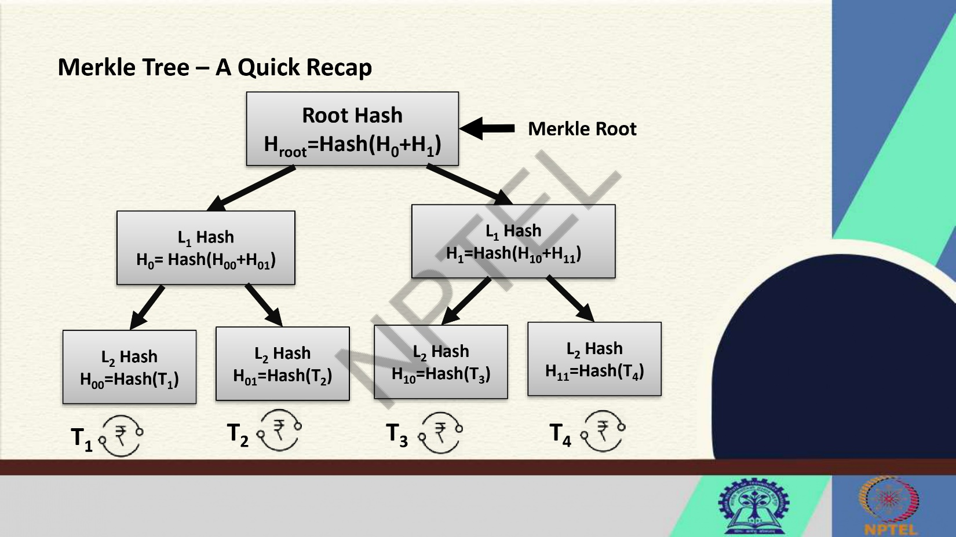
- At the lowest level of the tree are the individual transactions (or data elements).
- Each transaction is hashed individually to create a hash value.
- These hash values are then paired and hashed together to create a new set of hash values.
- This process continues until a single hash value, the Merkle root, is obtained at the top of the tree.

By including the Merkle root in the block header, any change in a transaction would require changing all subsequent hash values up to the Merkle root. This property makes it computationally infeasible to tamper with the data in a block without detection, as changing even a single transaction would lead to a mismatch in the Merkle root.

Overall, the Merkle tree structure provides a secure and efficient way to verify the integrity of data in a block, ensuring the immutability and trustworthiness of the blockchain [T3].

- Discuss RSA algorithm for key generation and verification with an example.
Ans.4) The RSA algorithm is a widely used asymmetric cryptographic algorithm for secure data transmission and digital signatures. It involves key generation, encryption, and decryption processes. Here is a detailed explanation of the RSA algorithm for key generation and verification with an example:

1. Key Generation:
- Select two large prime numbers, p and q.
- Calculate the modulus, n, as n = p * q.
- Compute Euler's totient function, φ(n), as φ(n) = (p-1) * (q-1).
- Choose a public exponent, e, such that 1 < e < φ(n) and gcd(e, φ(n)) = 1
(e is usually a small prime like 3 or 65537).
- Calculate the private exponent, d, as the modular multiplicative inverse of e modulo φ(n)
(i.e., d * e ≡ 1 (mod φ(n))).
- The public key is (e, n) and the private key is (d, n).

2. Example:
- Let's consider p = 17 and q = 11.
- Calculate n = p * q = 17 * 11 = 187.
- Compute φ(n) = (p-1) * (q-1) = 16 * 10 = 160.
- Choose e = 7 (a common choice).
- Determine d such that d * e ≡ 1 (mod 160); we find d = 23 since 23 * 7 ≡ 161 ≡ 1 (mod 160).
- Therefore, the public key is (7, 187) and the private key is (23, 187).

3. Key Verification:
- To verify a signature or decrypt a message encrypted with the public key, the recipient uses the private key.
- The recipient applies the private exponent, d, to the ciphertext to recover the original message or signature.
- If the decrypted message matches the original plaintext or the signature is valid, the verification is successful.

In summary, the RSA algorithm involves generating a public-private key pair, where the public key is used for encryption and signature verification, while the private key is used for decryption and signing. The security of RSA relies on the difficulty of factoring large composite numbers.
- Alice employs the RSA cryptosystem with the prime numbers P=7 and Q=17 toderive her public and private keys. Given that Alice’s public key is 11 , what will be her private key?
Ans. 5) To determine Alice's private key using the RSA cryptosystem with the prime numbers P = 7 and Q = 17, and knowing that her public key is 11, we can follow these steps:

1. Calculate the modulus, n:
n = P * Q
n = 7 * 17
n = 119

2. Compute Euler's totient function, φ(n):
φ(n) = (P-1) * (Q-1)
φ(n) = 6 * 16
φ(n) = 96

3. Given that Alice's public key is e = 11, we need to find her private key, d, such that:
d * e ≡ 1 (mod φ(n))

4. To find d, we need to calculate the modular multiplicative inverse of e modulo φ(n):
d ≡ e^(-1) (mod φ(n))

5. Using the Extended Euclidean Algorithm or other methods to find the modular multiplicative inverse, we can calculate:
11 * d ≡ 1 (mod 96)

6. Solving the above congruence equation, we find that Alice's private key, d, is:
d = 11^(-1) mod 96
d = 11^(-1) mod 96
d = 11^71 mod 96
d = 59

Therefore, Alice's private key in this scenario, where her public key is 11 and the prime numbers are P = 7 and Q = 17, would be 59.

- Explain evolution of blockchain.
Ans. 6) The evolution of blockchain technology has been a fascinating journey that has transformed the way we perceive and utilize digital transactions. Here is a brief overview of the key milestones in the evolution of blockchain:

1. Pre-Bitcoin Era:
- The concept of a blockchain-like structure was first introduced by Stuart Haber and W. Scott Stornetta in 1991 to timestamp digital documents cryptographically.
- In 1998, Nick Szabo conceptualized "Bit Gold," a decentralized digital currency system that laid the groundwork for future cryptocurrencies.

2. Bitcoin and Proof of Work:
- In 2008, an individual or group using the pseudonym Satoshi Nakamoto published the Bitcoin whitepaper, introducing the concept of a peer-to-peer electronic cash system.
- The launch of Bitcoin in 2009 marked the beginning of blockchain technology as we know it today, with its decentralized, immutable, and transparent ledger.
- Bitcoin's consensus mechanism, Proof of Work (PoW), revolutionized trustless transactions by enabling a decentralized network to validate and secure transactions.

3. Altcoins and Diversification:
- Following the success of Bitcoin, alternative cryptocurrencies (altcoins) like Litecoin (2011) and Ethereum (2015) were introduced, each with unique features and use cases.
- These altcoins expanded the blockchain ecosystem, showcasing the versatility of blockchain technology beyond digital currencies.

4. Smart Contracts and Decentralized Applications (DApps):
- Ethereum introduced smart contracts, self-executing contracts with the terms of the agreement directly written into code. This innovation enabled the development of decentralized applications (DApps) on the blockchain.
- The rise of DApps opened up new possibilities for decentralized finance (DeFi), non-fungible tokens (NFTs), and other blockchain-based applications.

5. Enterprise Adoption and Interoperability:
- Enterprises recognized the potential of blockchain for enhancing transparency, security, and efficiency in various industries, leading to initiatives like Hyperledger and R3 Corda.
- Interoperability solutions like Polkadot and Cosmos emerged to facilitate communication and data exchange between different blockchains, fostering a more connected blockchain ecosystem.

6. Evolution of Consensus Mechanisms:
- Beyond PoW, new consensus mechanisms like Proof of Stake (PoS), Delegated Proof of Stake (DPoS), and Proof of Authority (PoA) were developed to address scalability, energy efficiency, and governance issues.

7. Institutional Adoption and Regulation:
- Institutional investors and governments started showing interest in blockchain technology, leading to the development of regulatory frameworks and initiatives to integrate blockchain into traditional financial systems.

8. Future Trends:
- The evolution of blockchain continues with advancements in scalability, privacy, interoperability, and sustainability, paving the way for Web3.0 and the decentralized internet of the future.

This brief overview highlights the significant milestones in the evolution of blockchain technology, showcasing its transformative impact on various industries and paving the way for a more decentralized and secure digital future.
The evolution of blockchain technology can be traced through several key stages:

1. Inception of Blockchain: The concept of blockchain was first introduced in 2008 by an unknown person or group of people using the pseudonym Satoshi Nakamoto in a whitepaper titled "Bitcoin: A Peer-to-Peer Electronic Cash System." This paper laid the foundation for the first blockchain-based cryptocurrency, Bitcoin.

2. Bitcoin Network and Creation of Coins: The Bitcoin network was launched in 2009, marking the beginning of the first successful implementation of blockchain technology. Through a process called mining, new bitcoins are created and transactions are recorded on the decentralized ledger known as the blockchain.

3. Variation of Block Reward with Time: Initially, the block reward for mining a new block on the Bitcoin blockchain was set at 50 bitcoins. However, this reward is halved approximately every four years in a process known as the "halving," designed to control the supply of bitcoins and mimic the scarcity of a finite resource like gold.

4. Handling of Double Spending Problem: One of the key challenges in digital currencies is the double-spending problem, where the same digital token is spent more than once. Blockchain technology solves this issue by ensuring that each transaction is verified and recorded on a distributed ledger, making it nearly impossible to alter or duplicate transactions.

5. Payment using Bitcoin and Anonymity: Bitcoin transactions provide a certain level of anonymity as they are pseudonymous, meaning that users are identified by their wallet addresses rather than personal information. This feature has made Bitcoin popular for online payments and transactions where privacy is valued.

6. Blockchain Applications Beyond Bitcoin: Over time, blockchain technology has evolved beyond cryptocurrencies like Bitcoin to find applications in various industries such as supply chain management, healthcare, finance, and voting systems. These applications leverage the transparency, security, and immutability of blockchain ledgers to streamline processes and enhance trust.

7. Emergence of Altcoins and Diverse Blockchain Platforms: Following the success of Bitcoin, numerous alternative cryptocurrencies (altcoins) have been developed, each with its unique features and use cases. Additionally, various blockchain platforms like Ethereum, Ripple, and Hyperledger have emerged, offering smart contract functionality, faster transaction speeds, and scalability improvements.

8. Integration of Blockchain with Emerging Technologies: Blockchain technology is increasingly being integrated with other emerging technologies such as artificial intelligence, Internet of Things (IoT), and big data analytics to create innovative solutions for complex challenges. This convergence is driving the next phase of blockchain evolution towards more interconnected and efficient systems.

By understanding the historical development and ongoing advancements in blockchain technology, we can appreciate its transformative potential across diverse sectors and anticipate further innovations in the future.

